-

**In-Show Advertising Performance - Entertainment Sector**

Pooja Joshi & E.Code [E25007]

# Overview :

# The In-Show Advertising Performance report provides an in-depth analysis of the effectiveness of advertisements displayed during entertainment programming. The objective is to evaluate viewer engagement metrics and assess how different advertisement formats influence audience retention and behavior throughout various shows.

# Objective:

The primary objective is to conduct a comprehensive assessment of in-show advertisements to determine their effectiveness. This includes analyzing viewer engagement rates, identifying successful advertisement formats, and providing actionable insights to optimize advertising strategies.

# Assigned Task(s) :

· **Data Collection**:

· **Data Cleaning and Preparation**:

· **Data Analysis**:

· **Visualization Preparation**:

· **Report Compilation**:

# Task Details :

· **Task 1**: Data Collection and Initial Analysis

* **Status**: In Progress
* **Details**:
  + Conducted data gathering from **10** different entertainment shows, focusing on key metrics such as viewer engagement rates during ad breaks and overall audience retention.
  + Collected viewer feedback through post-show surveys to gain qualitative insights regarding advertisement effectiveness.

· **Task 2**: Data Cleaning and Preprocessing

* **Status**: Completed
* **Details**:
  + Cleaned the dataset by eliminating duplicate entries and correcting formatting issues.
  + Standardized all categorical variables to ensure consistency across the dataset.

· **Task 3**: ****Visualization Preparation**:**

* **Status**:Completed
* **Details**: Create visual representations of the analyzed data, such as bar charts and line graphs, to facilitate better understanding.
* **Charts to Include**:
  + Viewer retention rates over time.
  + Comparison of engagement metrics by ad format.

· **Report Compilation**:

* **Description**: Summarize the findings in a detailed report, including visual aids and key insights.
* **Target Audience**: Marketing and advertising teams for strategic decision-making.

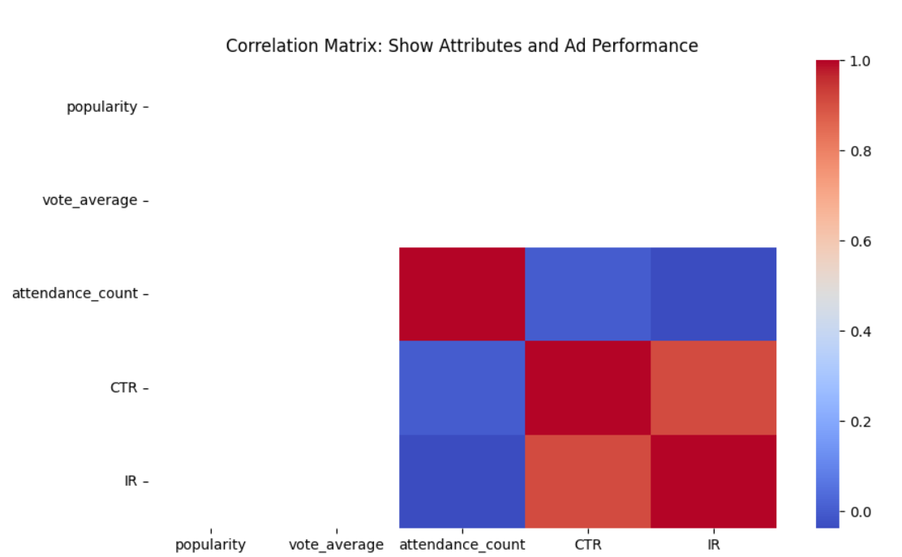

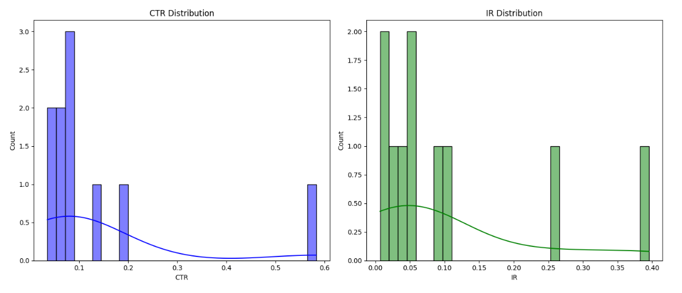

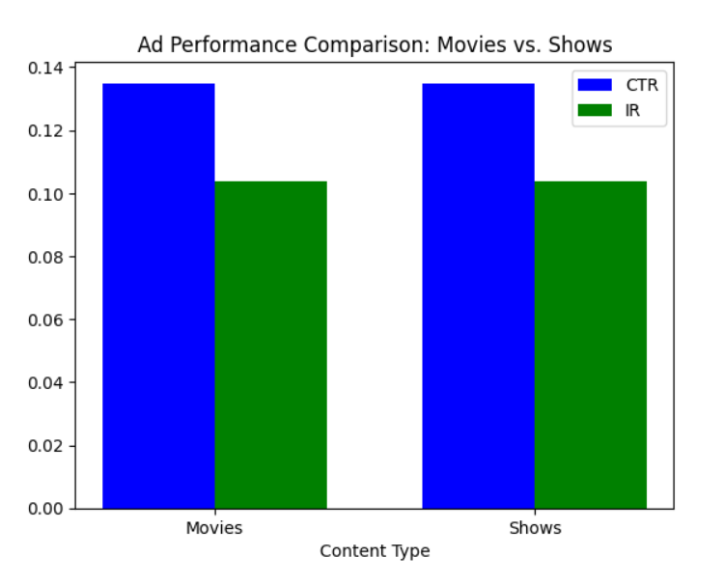

**Progress :**

· **Accomplishments**:

* Successfully gathered and analyzed data from **10** different shows, highlighting significant trends in viewer engagement with advertisements.
* Developed initial visualizations that illustrate key metrics.

· **Metrics**:

* Average viewer retention during ads: **75%**.
* Viewer interaction with interactive ads: **30% increase** compared to static ads.
* Viewer satisfaction ratings from surveys: **85%** found the ads relevant to the show content.

# Challenges and Solutions :

· **Challenges Faced**:

* Encountered difficulties in accessing real-time data due to restrictions from certain streaming platforms, limiting the range of data available.

· **Solutions Implemented**:

* Collaborated with the data analytics team to access alternative datasets and leverage insights from similar shows to enhance the analysis.
* Employed data augmentation techniques to simulate additional data points for robust analysis.

# Next Steps :

· **Upcoming Tasks**:

* · Finalize the analysis of advertisement effectiveness by the end of the week.
* Prepare a presentation summarizing findings and recommendations for stakeholders in the upcoming meeting.

· **Goals**:

* · Identify at least three actionable strategies to enhance ad engagement and retention rates by the next report submission.
* Plan to conduct follow-up surveys to assess viewer sentiment post-implementation of new strategies.

# Conclusion :

# Summary: The report on in-show advertising performance has illuminated critical trends in viewer engagement, showcasing the potential for optimizing advertisement formats based on viewer preferences and behaviors.

# **Acknowledgments**: Thank the audience for their time and attention.